24-10-2021

ABHINAV RANJAN

RA1911003010003

CSE A1 SECTION

SRMIST , KTR

CN LAB EXP 15

PPP configuration

Introduction

PPP is a non-proprietary WAN data-link layer encapsulation protocol which can be viewed as an enhancement of HDLC as it embeds many additional features when compared with HDLC:

* PPP Authentication. Supported authentication protocols are PAP and CHAO
* Compression
* Error detection
* Multilink to provide load-balancing over multiple network interfaces

Network diagram

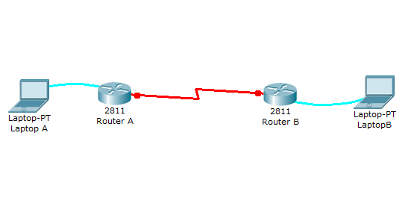

This lab will test your ability to configure PPP on a serial link in Packet Tracer 8.0. Practicing this labs will help you to better understand what is a DCE, a DTE, and aclock rates on a serial router interconnection and make you ready for the CCNA ppp labs and simlets.

1. Use the connected laptops to find the DCE and DTE routers. You can connect to the routers using CLI.

2. Configure the routers with the following parameters :

- Clock : 250000  
- PPP link between the routers  
- DCE IP : 192.168.10.5/30

- DTE IP : 192.168.10.6/30

3. Check IP connectivity between the two routers using the ping command.

**1. Use the connected laptops to find the DCE and DTE routers**

The**show controllers <serial interface>** command is used to determine which side of the cable is the DCE side.

In this example, Router-A is the DTE side, and Router-B the DCE side (DCE V.35, clock rate set).

Router-A#show controllers serial 0/0/0

Interface Serial0/0/0

Hardware is PowerQUICC MPC860

DTE V.35 TX and RX clocks detected

Router-B#show controllers serial 0/0/0

Interface Serial0/0/0

Hardware is PowerQUICC MPC860

DCE V.35, clock rate 2000000

**2. Configure the routers with the following parameters**

Router-B beeing the DCE, clock rate has to be configured on Router-B serial 0/0/0 interface

Router-B(config)#interface serial 0/0/0

Router-B(config-if)#clock rate 250000

Then, configure PPP encapsulation and IP address on Router-B serial 0/0/0 interface. The **encapsulation ppp**configures PPP protocol on the serial interface. PPP authenication can be oprtionnally configured using the following IOS commands which are not used in this lab :

* ppp authentication : Set PPP link authentication method
* ppp pap:  Set PAP authentication parameters

Router-B beeing the DCE side of the serial link, the 192.168.10.5/30 IP address is configured on Router-B serial 0/0/0 interface. Don't forget to enable the interface with a **no shutdown** command.

Router-B(config)#interface serial 0/0/0

Router-B(config-if)#encapsulation ppp

Router-B(config-if)#ip address 192.168.10.5 255.255.255.252

Router-B(config-if)#no shutdown

The show interfaces serial 0/0/0 confirms that PPP encapsulation is enabled on the interface : *Encapsulation PPP, loopback not set, keepalive set (10 sec)*

Router-B#show interfaces serial 0/0/0

Serial0/0/0 is up, line protocol is up (connected)

Hardware is HD64570

Internet address is 192.168.10.5/30

MTU 1500 bytes, BW 1544 Kbit, DLY 20000 usec,

reliability 255/255, txload 1/255, rxload 1/255

Encapsulation PPP, loopback not set, keepalive set (10 sec)

Last input never, output never, output hang never

[...]

Finally, configure PPP encapsulation and IP address on Router-A serial 0/0/0 interface. The link becomes up as both routers are correctly configured.

Router-A(config)#interface serial 0/0/0

Router-A(config-if)#encapsulation ppp

Router-A(config-if)#ip address 192.168.10.6 255.255.255.252

Router-A(config-if)#no shutdown

%LINK-5-CHANGED: Interface Serial0/0/0, changed state to up

**3. Check IP connectivity between the two routers using the ping command.**

Issue a ping from Router-A to Router-B to test network connectivity between the two routers.

Router-A#ping 192.168.10.5

Type escape sequence to abort.

Sending 5, 100-byte ICMP Echos to 192.168.10.5, timeout is 2 seconds:

!!!!!

Success rate is 100 percent (5/5), round-trip min/avg/max = 3/3/4 ms

Screenshots:

